# Mean reverting strategy (minute data)

1. cex eth/usd price ->xt
2. Liquid eth/usd price -> yt
3. Yt = beta * xt + et, johansen test; cadf test; for cointegration; maybe also test et - shapiro–wilk normal, graph et
4. Regress ar1 for et, -> obtain look back period = half life time <https://flare9xblog.com/tag/half-life/>
5. Zscore mean reverting strategy. Entry level = absolute Z score > 0.8; exit next minute; e.g. assume beta = 1.02, if Z score < -0.8, buy 1eth y and sell 1.02 eth at x

advance

1. Multiple entry level? Multiple exit level? – no
2. Kalman filtering

# R back testing result

## Data description

1. Data: cex and quoinex eth/usd minute data from Oct-01-2018 to Jan-01-2019
2. Traing data: Oct-01-2018 to Nov-19-2018 (70000obs)
3. Out of sample data: Nov-19-2018 to Jan-01-2019

## Training results:

1. Yt = 1.01xt +et. Yt = quoienx; xt = cex
2. Lookback period = 36 minutes

## Strategy using out of sample data

1. Construct et = yt – 1.01xt
2. MA_et = 1/36 * sum of et from t to t-35
3. Standard deviation of et from t to t-35
4. Calculate the z score = (et – Ma_et) / standard deviation
5. If z score > 0.8, we sell et for the size = zscore, if z score < -0.8, we buy et at the size = z score
6. Exit after 1 minute (holding exact 1 minute and close position at the close price of both exchanges). This is a rather basic exit strategy which is easy to backtest and implement, could be adjusted easily after the pilot version has been coded.

The data look like this where mktVal = - zscore; execite is how much we buy/sell et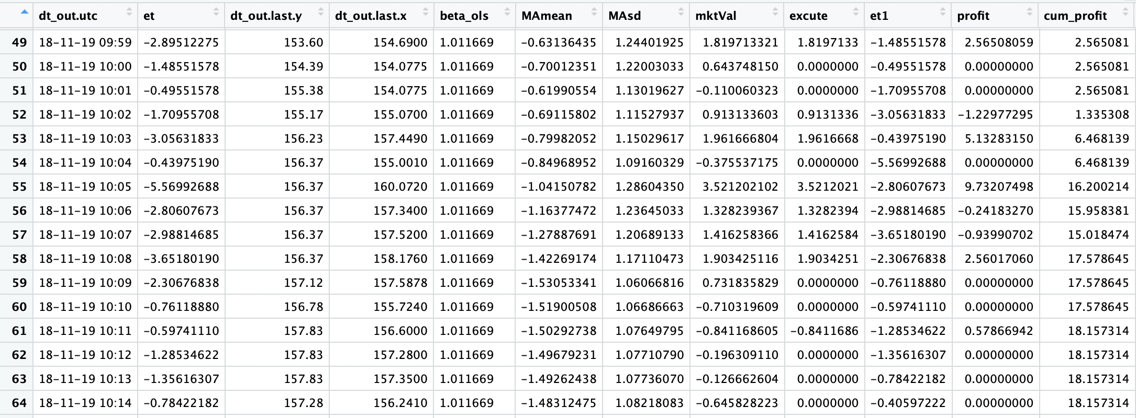

## Result

Every minute profit : 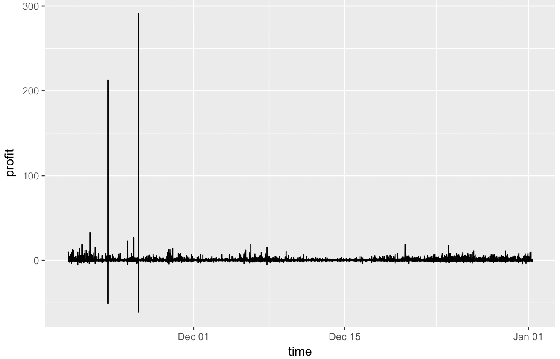

Summary of the statistics of profit. The max and small profit is due to in November there is a large price surge exclusively in Quoinex (we have discussed this before).

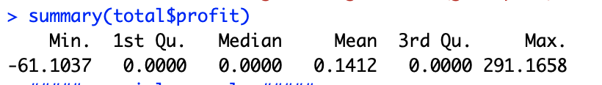

Summary of the statistics of execution ( execute = 5 means we we buy 5 unit (usd here) of et, so buy 5.05 yt and short 5 xt.) The NA is due to SD = 0 for some time hence execution = infinite = NA.

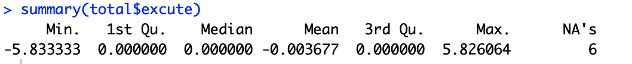

Cumulative profit

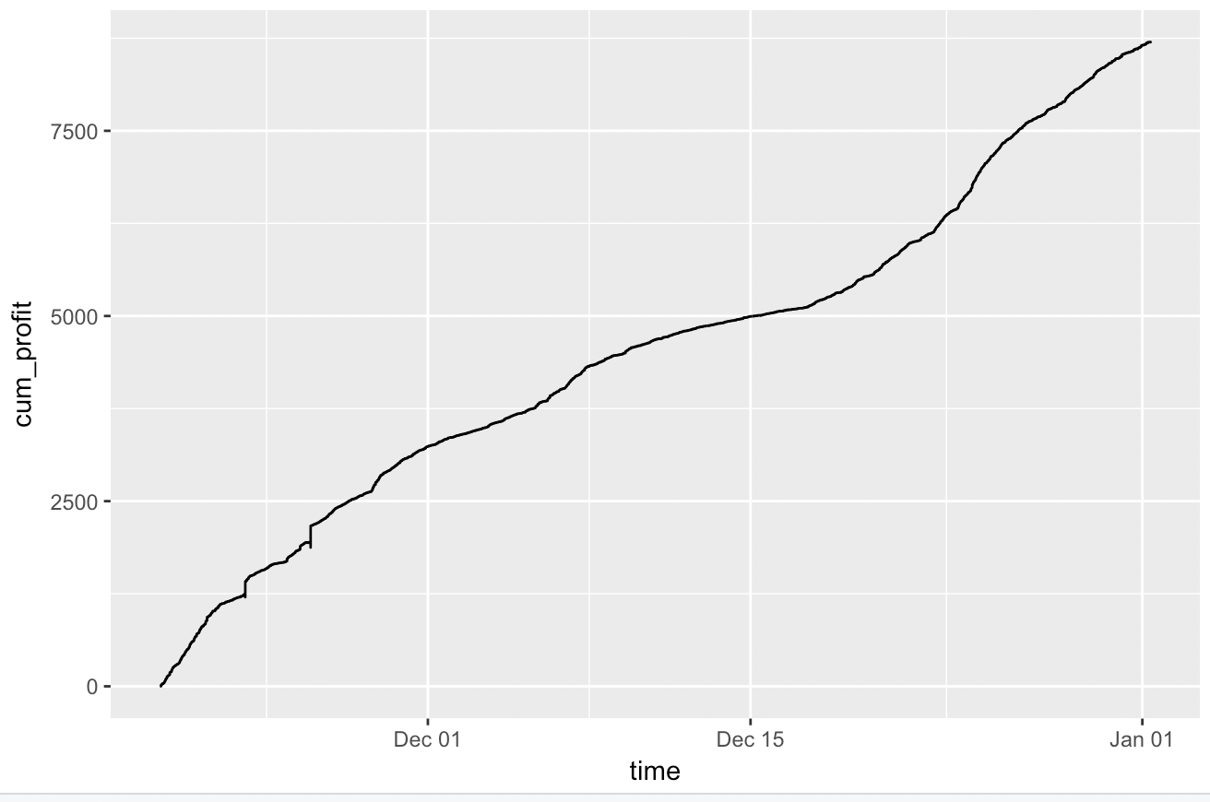

## Potential risk and problem

1. In the backtesting we assume there is no transaction fee.
2. In the backtesting we assume we buy/sell at the close price of time t (execute immediately after we obtain the information, in practice it depends on the order book that we may not market taking the last minute close price.
3. Sensitive to small data errors.

# Why choose these two exchange?

A. to simplify code, the very very basic version I only want to trade usd/eth; not other currency except usd.

B. the transaction fee is low

C. historical data pass the johansen test.

D. I didn’t make Gdax trader myself, so I don’t know if I can adjust that code, otherwise gdax should be better than cex. Exmo is hard to register a new account; kucoin withdraw fee is high.

The whole idea is just pick two easy to implement exchange to pilot maybe 1 eth for a month for the performance.

For future reference:

Intraday

1. Select all stocks near the market open whose returns from their previous day’s lows to today’s opens are lower than one standard deviation.The standard deviation is computed using the daily close- to-close returns of the last 90 days.These are the stocks that “gapped down.”
2. Narrow down this list of stocks by requiring their open prices to be higher than the 20-day moving average of the closing prices.
3. Buy the 10 stocks within this list that have the lowest returns from their previous day’s lows. If the list has fewer than 10 stocks, then buy the entire list.
4. Liquidate all positions at the market close.